8.102: a) The decrease in potential energy 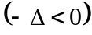 means that the kinetic energy increases. In the center of mass frame of two hydrogen atoms, the net momentum is necessarily zero and after the atoms combine and have a common velocity, that velocity must have zero magnitude, a situation precluded by the necessarily positive kinetic energy. b) The initial momentum is zero before the collision, and must be zero after the collision. Denote the common initial speed as , the final speed of the hydrogen atom as , the final speed of the hydrogen molecule as , the common mass of the hydrogen atoms as and the mass of the hydrogen molecules as 2. After the collision, the two particles must be moving in opposite directions, and so to conserve momentum, 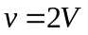. From conservation of energy,

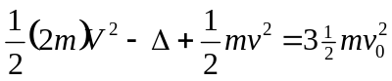
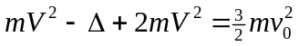
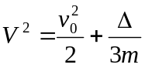,

from which 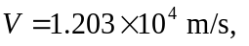or 1.20 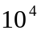 m/s to two figures and the hydrogen atom speed is 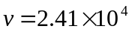 m/s.

